Universiteti i Prishtinës
UNIVERSITAS STUDIORUM PRISHTINIENSIS
Nëna Terezë, 10000 Prishtinë, Kosovë

Tel: +381-38-244183 URL: http://www.uni-pr.edu
Fax: +381-38-244187 Mail: rektorati@uni-pr.edu

Curriculum vitae

Name and surname: Elmaze NURA
Academic Degree: Associate Professor
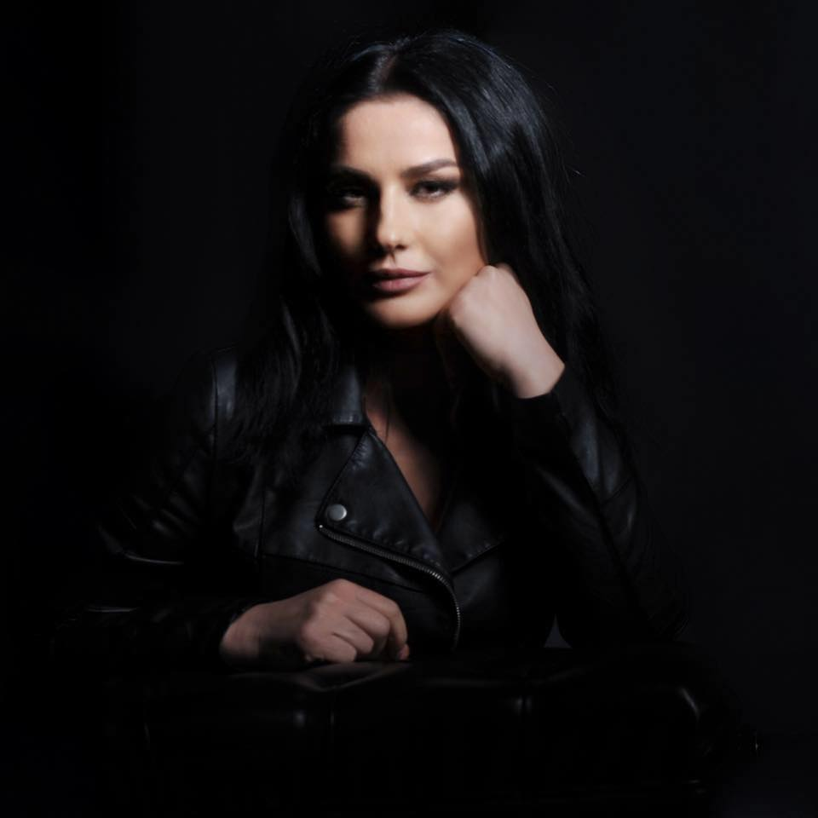

- Job Experience:
2018 - presnt – Founder and Manager of the “Theatre Conference”
2018 – present - Chief of the Theatre Directing Program, Art Faculty, University of Prishtina, Kosovo
2014- present – Founder and Director of the Summer Festival “Summer Cult”
2013 – March – October : General Director of National Theatre of Kosovo
1. General Director of the Public Theater has the following responsibilities:
1.1. makes financial management, administrative, technical and theater promoter;1.2. implements decisions of the Board of Theatre;
1.3. proposes internal organization of the theater to the Board;
1.4. represents theater within and abroad domestic;
1.5. proposes the annual budget in front of the Board of Directors;
1.6. requires, apply and negotiate for making donations;
1.7. follows the budget revenues and expenditures and donations.
1.8. negotiates and signs contracts and agreements with independent artists and other
parties.
1.9. manages the maintenance and security of the theater building.
1.10. manages cooperation in national and international level.
1.11. for his work responses and reports to the Governing Council.
1.12. performs other duties prescribed by law and statute.
2016- Associate Professor – Theater Directing, Art Faculty, University of Prishtina, Kosovo
2013 – Secretary General of International Theatre Institute, Centre Kosovo
2012-2015 –Coordinator of Accademic Development, Art Faculty, University of Prishtina, Kosovo
2012-Chief of Theatre Direcing Program, Art Faculty, University of Prishtina, Kosovo
2011- Professor Assistant – Theater Directing, Art Faculty, University of Prishtina, Kosovo
2009 (January- May) – Co-teaching - Department of Theatre and Film at the Kansas University, USA
2008 -Assistant – Theater Directing, Art Faculty, University of Prishtina, Kosovo
2006 – Present – Founder and Director of NGO “CultClub”
- The artistic and scholarly qualification:

2006 - 2009 PRISHTINA UNIVERSITY Prishtina, Kosove

October 24th 2009 earned MA title of:

MASTER OF ARTS
Theater Directing

University of Prishtina was founded with the Law on the Foundation of the University of Prishtina, which was approved by Socialist Province of Kosova Assembly on November 18th 1969.
The Faculty of Arts was established in 1973, as the Academy of Fine Arts. Two years later, the Department of Musical Arts was established within the Faculty, and in 1989 the Department of Dramatic Arts was added. Currently, the Facutly offers study in three departments: Fine Arts, Drama and Music.
www.uni-pr.edu

2006- 2009 KIJAC Prishtina, Kosove
(Kosove Institute for Journalism and Communication)

May 7th 2009 earned MA title of:
MASTER OF ARTS
Journalism and Communication
Established in 2005, KIJAC’s two-year Master’s program, enables students to explore the profession of journalism through employing state-of-the-art digital technologies, guided by both staff lecturers and various international lecturers, most of them seasoned international journalists with strong background from news organizations such as British Broadcasting Corporation (BBC), Norwegian Broadcasting Corporation (NRK), the Daily Telegraph, TIME Magazine, etc.
The combination of rich and diverse academic backgrounds between local and international lecturers at KIJAC provides an important intellectual agent that assists enormously in broadening of the views of KIJAC students on global/local role of the media, professional trends and current academic developments. This master is offered only in English Language.
www.kijac.org

2000 – 2005 PRISHTINA UNIVERSITY Prishtine, Kosove

Art Faculty
Earned BA Degree of:
Theater Director

The Faculty of Arts was established in 1973, as the Academy of Fine Arts. Two years later, the Department of Musical Arts was established within the Faculty, and in 1989 the Department of Dramatic Arts was added. Currently, the Facutly offers study in three departments: Fine Arts, Drama and Music.
www.uni-pr.edu

FELLOWSHIPS______________________________________________________
January 2009 – May 2009 JFDP Kansas, USA

JFDP Alumni
- The Junior Faculty Development Program (JFDP) is a program of Bureau of Educational and Cultural Affairs (ECA) of the U.S. Department of State. JFDP is administered by American Councils for International Education: ACTR/ACCELS. JFDP is a non-degree, professional development program that provides promising junior university faculty with the opportunity to: expand knowledge and expertise in their respective academic fields by attending classes and working with faculty members at universities in the United States; garner new educational perspectives with exposure to U.S. educational philosophy and methods; gather new academic materials and resources, and; forge relationships between U.S. universities and their home universities, in order to support ongoing contact and collaboration.
- Department of Theatre and Film at the Kansas University gave me a great opportunity to get involved in co teaching in the Undergraduate Level with Prof. Mechele Leon.
http://www.jfdp.org/

TRAININGS_________________________________________________________

2007 LONDON SCHOOL OF PUBLIC RELATIONS Prishtine,Kosove
LASPR
Course – Certificate

The London School of Public Relations and Branding (LSPR) was established in 1992 and is now one of the leading educational bodies offering training in Public Relations, branding and reputation management.
http://www.pr-school-london.com/

2003 ART MANAGEMENT Ohrid, Macedonia
Course – Certificate
- This course aimed at increasing management skills of Kosovar leaders/managers of arts and culture institutions, specifically young artists.

THEATER PERFOMANCES
- WOMEN IN PARLAMENT - 2021
Professional Theatre “Adriana”
Director – Elmaze Nura
Adaptation – Elmaze Nura
Author- Aristophanes
Ferizaj, Kosovo

- The Mistress of INN - 2019
Professional Theatre “Istref Begolli”
Director – Elmaze Nura
Author- Carlo Gordon
Peje, Kosovo

- The Miser - 2019
Professional Theatre “Adriana”
Director – Elmaze Nura
Author- Moliere
Ferizaj, Kosovo

- UNFINISHED PORTRAIT - 2017
Dodona Theatre
Director – Elmaze Nura
Author- Besim Rexhaj
Adaptation – Elmaze Nura
Prishtine, Kosovo

- UBU ROI - 2016
National Theatre of Kosovo /producer ITI Kosovo
Director – Elmaze Nura
Author- Alfred Jarry
Adaptation – Elmaze Nura
Prishtine, Kosovo

- DIABOLIC MINDS – 2015
“ISTREF BEGPLLI” Theatre
Director – Elmaze Nura
Author - Blerim Haxhiaj
Peje, Kosovo

- TROJAN WOMEN - 2015
National Theatre of Kosovo / producer Theatre and Movie House AKT
Director – Elmaze Nura
Author- Euripidi
Adaptation – Elmaze Nura
Prishtine, Kosovo

- AMOK - 2014
National Theatre o f Kosovo/ producer Theatre and Movie House AKT
Director – Elmaze Nura
Author: Nina Mazur, after Stefan Zweig
Prishtine, Kosovo

- WHERE…WHAT?! - 2013
Dodona Theatre
Director: Elmaze Nura
Author: Elmaze Nura and Mentor Zymberaj
Prishtine, Kosovo

- THE OPEN COUPLE - 2012
“ISTREF BEGOLLI” Theatre
Director –Elmaze Nura
Author- Dario Fo, Franca Rame
Peja, Kosove

- LYSISTRATA - 2012
National Theatre of Kosovo
Director – Elmaze Nura
Author- Aristifani,
Adaptation - Elmaze Nura
Prishtine, Kosove

- TROJAN WOMEN - 2012
Dodona Theatre
Director – Elmaze Nura
Author- Euripidi
Adaptation – Elmaze Nura
Prishtine, Kosovo

- PARFUME SHOP – 2011
Dodona Theatre
Director – Elmaze Nura
Author: Haqif Mulliqi
Prishtine, Kosove

- ZOO STORY 2010
Dodona Theatre
Director – Elmaze Nura
Author: Edward Albee
Prishtine, Kosove

- BENI – 2009
Kansas University
Stage reading director – Elmaze Nura
Author - Zymber Kelmendi
Kansas, USA

- THE ACCIDENTAL DEATH OF AN ANARCHIST - 2008
Theatre of Nationalities
Director – Elmaze Nura
Author: Dari Fo
Skopje, Macedonia

- KNOCKING… - 2007
Theatre of City Gjilan
Director – Elmaze Nura
Author- Fadil Hysaj
Gjilan, Kosovo

- DESPERATE HUSBANDS - 2006
Dodona Theatre
Director – Elmaze Nura
Author-Aldo De Bendeti
Prishtine, Kosovo

- DON’T TOUCH IT… -2005
Theatre of City Gjilan
Director – Elmaze Nura
Author- Zymber kelmendi
Gjilan, Kosovo

- THE SEAGULL - 2003
National Theatre of Kosovo
Director – Elmaze Nura
Author- Anton Chekhov
Prishtine, Kosovo
- THE MIDSUMMER NIGHT’s DREAM - 2002
Germia Park
Director – Elmaze Nura
Author- William Shakespeare
Prishtine, Kosovo

FESTIVALS AND PRESENTATIONS:
- 2003 Cairo International Festival for Experimental Theater, Egypt
- 2005 Malta, Theater Festival, Poznan, Poland
- 2005 Kumanove, Macedonia
- 2005 Diber, Macedonia
- 2008 Skupifest, Skopje, Macedonia
- 2008 Tuz, Montengero
- 2010 National Theater Festival, Therande, Kosovo
- 2011 Bridge with three Arches, Tetovo, Macedonia
- 2012 International Theatre of Comedy Kumonavo, Macedonia
- 2012 International Theatre Festival of Skampa, Elbasan, Albania
- 2013 International Theatre Festival, Klaipeda, Lithuania
- 2013 International Theatre Festival , EXPONTO, Ljubljnana, Slovenia
- 2013 International Theatre Festival , “Risto Siskov”, Strumice, Mecedonia
- 2013 National Theatre Festival of Theatre,Gjakove, Kosovo
- 2013 International Theatre Festival of Comedy, Kumanovo, Macedonia
- 2013 National Theatre Festival, Ferizaj, Kosovo
- 2013 International Theatre Festival of “Skampa” , Elbasan, Albania
- 2013 Nationwide Théâtre Festival, Presevo, Serbia
- 2013 International Theatre Festival – InterFest 2013, Pitesti, Romania
- 2014 Fujairah International Monodrama Festival, Fujairah, Emirates
- 2014 International Theatre of Frankfurt, Germany
- 2014 International Balkan Theatre Festival of Bursa, Turkey
- 2014 International Festival of Monodrama “MonoAKT”, Peje, Kosovo
- 2014 Summer Festival “SUMMERCULT”, I Edition, Prishtina, Kosovo
- 2014 International Festival of Monodrama, Bitola, Macedonia
- 2014 International Festival of Monodrama, Bitola Bishkek, Kirgizstan
- 2014 International Theatre Festival –Davila Interfest 2014, Pitesti, Rumania
- 2015 International Balkan Theatre Festival of Bursa, Turkey
- 2015 International Theatre Festival “Saint Muse”, Ulaanbaatar, Mongolia
- 2015 International Theatre Festival – Monoakt – 2013 – Peje, Kosovo
- 2015 Summer Festival “SUMMERCULT”, II Edition, Prishtina, Kosovo
- 2015 International Theatre Festival –Davila Interfest 2015, Pitesti, Rumania

- 2015 International Theatre Festival “Alone on the Stage”, Trencin, Slovak Republic
- 2016 Fujairah Arts Festival, Fujairah, Emirates
- 2016 Summer Festival “SUMMERCULT”, III Edition, Prishtina, Kosovo
- 2016 International Theatre Festival –Davila Interfest 2016, Pitesti, Rumania
- 2017 International Theatre Institute - World Day of Theatre, Paris, France, Honor Guest
- 2017 International Theatre Institute - 35 World Congers, Segovia, Spain
- 2017 International Theatre Festival – Theatre without Borders, Tuzla, Bosnje and Hercegovina
- 2017 International Theatre Festival- “VERTICAL”, Jerusalem, Israel
- 2017 International Theatre Festival – “De-Teater”, Fier, Albania
- 2017 Summer Festival “SUMMERCULT”, IV Edition, Prishtina, Kosovo
- 2017 IAPAR International Theatre Festival – Pune, India
- 2018 national Theatre Festival ,“Talia e Flakës”, Gjilan, Kosovo
- 2018 Fujairah International Arts festival FIAF- Fujairah, Emirates
- 2018 Colombo International Theatre festival, Colombo, Sri Lanka
- 2018 Summer Festival “SUMMERCULT”, V Edition, Prishtina, Kosovo
- 2019 Setcani/Encounter, Student Theatre Festival, Brno, Chek Republic
- 2019 International Monodrama Festival ‘Armono”, Yerevan, Armernia
- 2019 International Festival for Contemporary and Experimental Theatre, CIFCET, Caio, Egypt
- 2019 Nationwide Theatre Festival, Diber, North Macedonia
- 2019 Nationwide Théâtre Festival, Presevo, Serbia
- 2019 Summer Festival “SUMMERCULT”, VI Edition, Prishtina, Kosovo
- 2019 International Festival of Independent Performances – XVII Edition,
Vakhtangov Theatre, Moscow, Russia -2020
- Fujairah International ARTS Festival, Fujairah, Emirates, 2020

MEMBER OF JURY:
- 2020 Nationwide Theatre Festival, Diber, North Macedonia
- 2019 International Festival of Independent Performances - XVII Edition, Vakhtangov Theatre, Moscow, Russia
- 2019 Nationwide Theatre Festival “Days of Comedy” , Preshevo, Serbia
- 2019 National Theater Festival “Etno Fest”, Kosovo
- 2019 World Theatre Day Prize, Ministry of Culture of Kosovo
- 2013 International Theatre Festival – Monoakt –– Peje, Kosovo
- 2011International Theater Festival - Monoakt –- Peje, Kosovo
- 2010 International Theater Festival - Theater Different – Podujeve, Kosovo
- 2010 National Theater Festival – Ferizaj, Kosovo

AWARDS________________________________________________________

- BEST DIRECTOR
Best director of Year given by the Ministry of Culture of Republic of Kosovo for Annual Awards for Theatre 2019
- 2019 BEST DIRECTOR
October 2019
Nationwide Theatre Festival, Diber, North Macedonia

- 2018 BEST ACTRESS
January 2018
Winner with performance “Unfinished Portrait “, Talia e Flakës

- 2017 MOST INNOVATIVE DIRECTING AND EXCEPTIONAL ACTING
September 2017
Winner with the performance “AMOK”, in International Monodrama Festival “Vertical” in Jerusalem, Israel

May 2015 BEST DIRECTOR
2015 International Theatre Festival “Saint Muse”, Ulaanbaatar, Mongolia
Winner of the Prize for the BEST DIRECTOR, for the Play “AMOK” ,

November 2014 BEST SET DESIGN
- 2014 International Theatre Festival – InterFest 2014, Pitesti, Romania
Winner of the Prize for the BEST SET DESIGN, for the Play “AMOK” , designers: Elmaze Nura&Mentor Zymberaj .

November 2014 POPULARITY AWARD
- 2014 International Theatre Festival – InterFest 2013, Pitesti, Romania
Winner of the Prize for the Most Popularity Actor, for the AMOK .

October 2014 MOST HARMONIOUS SCNIC PLAY
- 2014 International Monodrama Festival, Bishkek, Kirgizstan
Winner of the Prize for the play AMOK .

April 2014 HARMONIOUS SCNIC PLAY
- 2014 International Monodrama Festival, Bitola, Macedonia
Winner of the Prize for the Harmonious Scenic Play, in the XVI International Monodrama Festival in Bitola, Macedonia.

November 2013 POPULARITY AWARD
- 2013 International Theatre Festival – InterFest 2013, Pitesti, Romania
Winner of the Prize for the Most Popularity Performance, for the Play, Where…What, text Elmaze Nura&Mentor Zymberaj .

November 2013 B EST DIRECTOR, BEST LEADNG ACTOR and BEST LEADING ACTRESS
- 2013 International Theatre Festival, Presevo, Serbia
Winner of the First Prize for the Best Directing, Best Leading Actror and Best Leading Actress for the Play ,Where…What, text Elmaze Nura&Mentor Zymberaj .

October 2013 BEST LEADING ACTOR
- 2013 National Theatre Festival, Ferizaj, Kosovo
Winner of the First Prize for the Best Leading Actror for the Play ,Where…What, text Elmaze Nura&Mentor Zymberaj .

Februar 2010 BEST LEADING ACTRESS & BEST SUPPORTING ACTRESS
- Winner of the First Prize for the Best Leading Actress and as well for Best Supporting Actress, for the Play , Zoo Story, at the National Festival, KosovaFest, in Therenda, Kosovo.

March 2009 FIRST PRIZE USA

- Winner of the First Prize in the Mid Term Virtual Conference
The conference was organized by American Council in Washington DC, for the 72 JFDP participants from Southeast Europe and Euro Asia.

2005 BEST ACTOR Diber, Macedonia

- The play - Don’t Touch it - at National Theatre Festival in Diber, won the award for the Best Actor.

CONFERENCES and WORSHOPS________________________________________
- 2020 Theatre Conference “Pandemic Theatre”, Third Edition
- 2019 Theatre Conference “Dimensions of Kosovar Theatre/Tradition and new Forms”, Second Edition
- 2019 Prishtina International Summer University PISU, 19’ Edition
- 2018 Theatre Conference “Theatre between Arts and Politics”, First Edition
- 2018 The workshop on “Body language and creating performance without text”, Colombo International Theater Festival, Colombo, Sri Lanka
- 2017 The workshops 'Innovative Theatre Directing and Acting', IAPAR International Theatre Festival, (Savitribai Phule Pune University), Pune, India
- 2017 Member of Forum for Theatre Training & Education FTTE
- 2017 International Theatre Institute (ITI) World Congress, Segovia, Spain.
- 2016 International scientific conference – Presentation of the research “The reconstruction of Kosovar national identity after 17 September 2008”, Tirane, Albania
- 2013 General Assembly of European Theatre Convention (ETC), representing National Theatre of Kosovo as a General Director, Tirane, Albania
- 2009 Virtual Conference , Junior Faculty Development Program, Washington, USA

PUBLICATIONS____________________________________________________

- Author of Monohgaph :“KOSOVO CULTURAL IDENTITY” (2020). Prishtinë, Armagedoni

- Translator of the Book: “Between Director and Actor”, (2019). Rees, Mandy and John Stanuinas. Prishtinë: Grafika Rezniqi

- Translator in the Book:“TEATROLOGJI, DREAMATURGJI, TEATËR DHE AKTRIM” (2007), Author: Fadil Hysaj

- Many reviews published in Daily Newspapers and Magazines about Theater Performances.

